ICT Internet Quiz
Our new topic is called ‘Effective Searching.’ In Lesson 1 I would like you to have a go at completing the quiz below. Circle the correct answer, then check your answers on the answer sheet below.
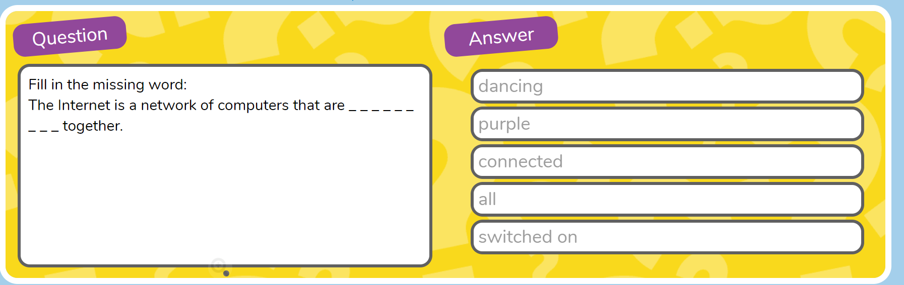
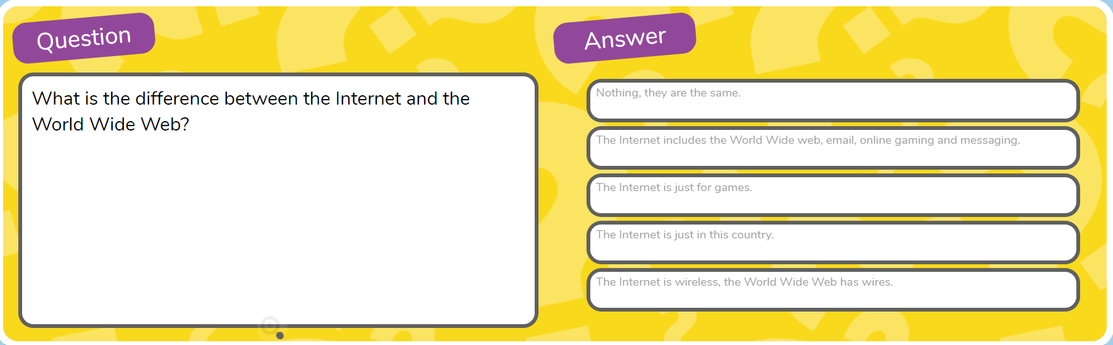
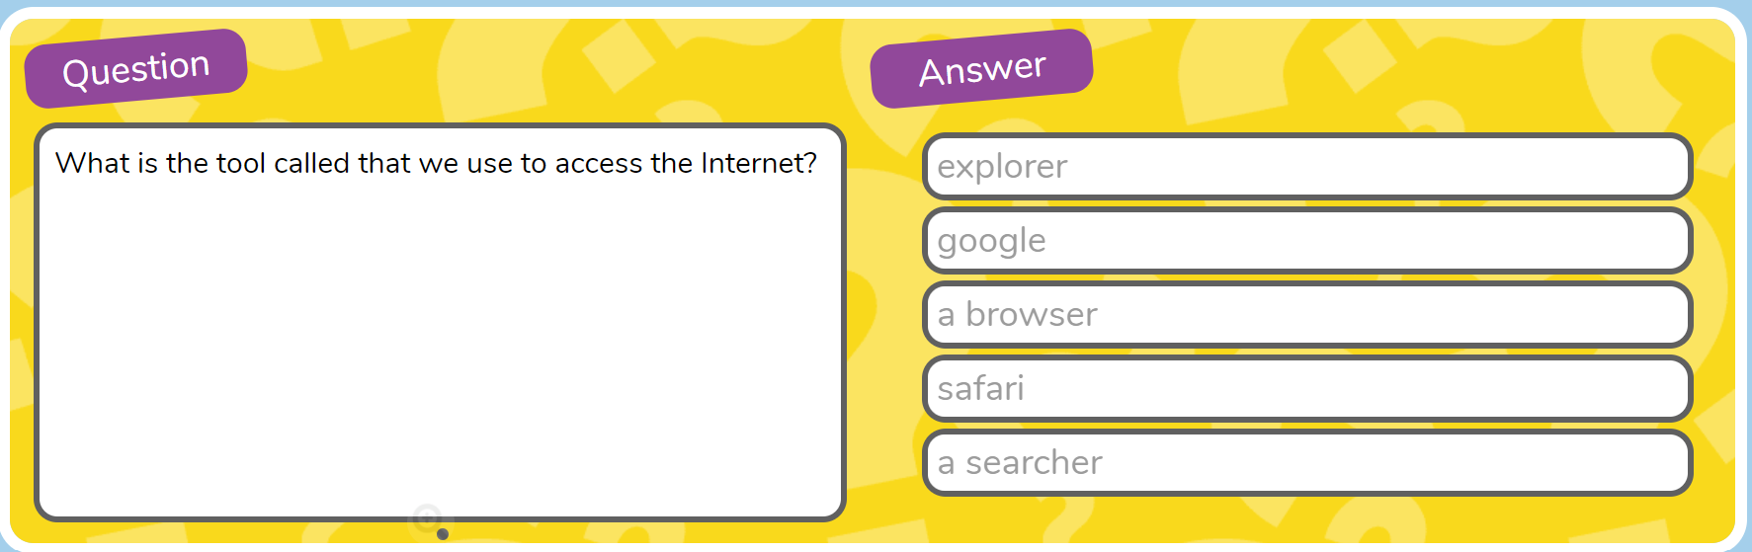
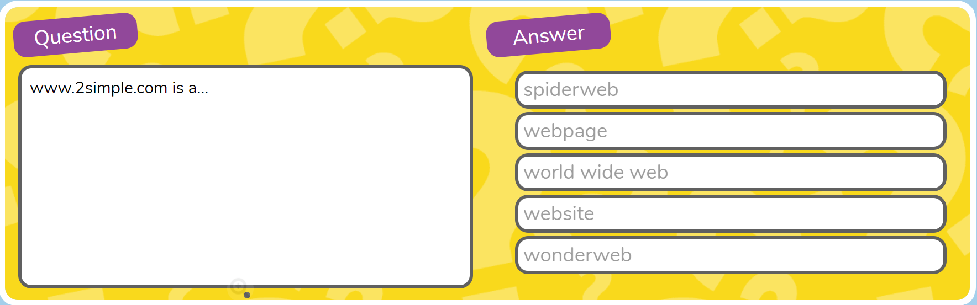
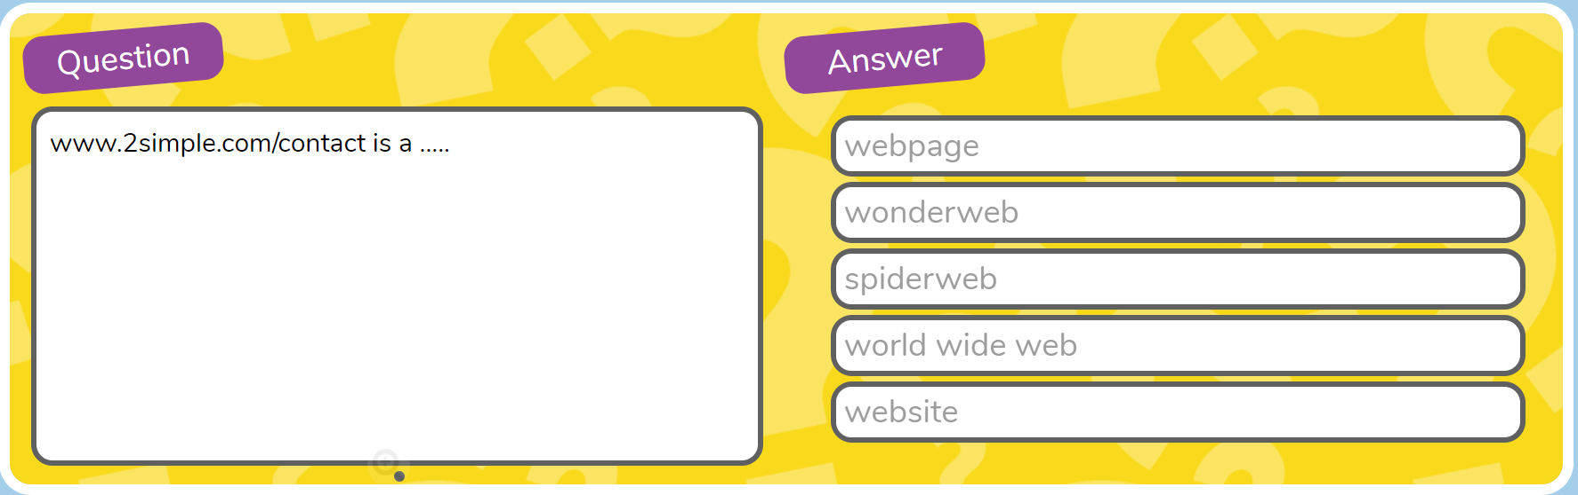

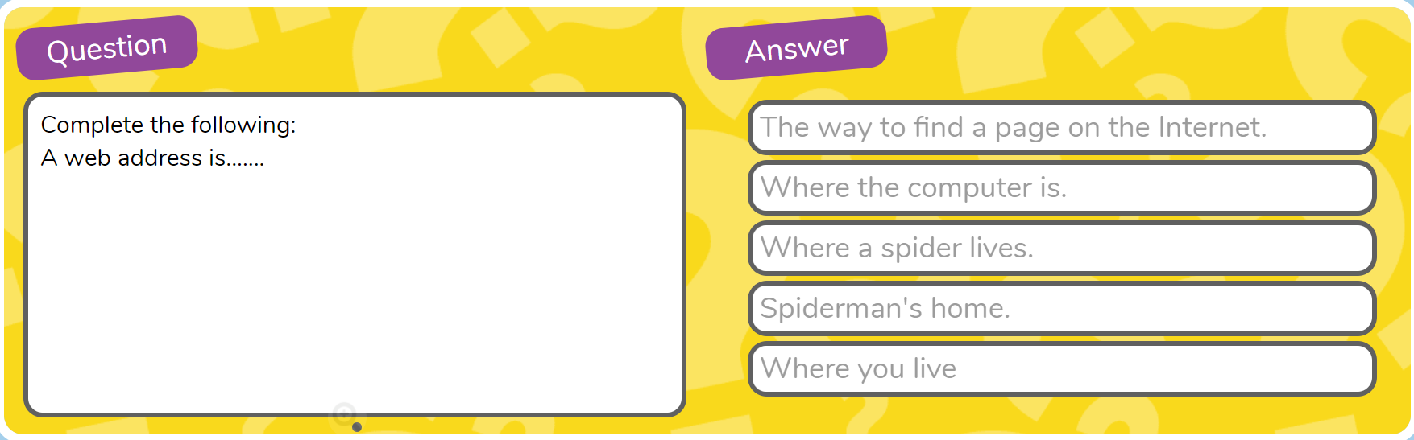

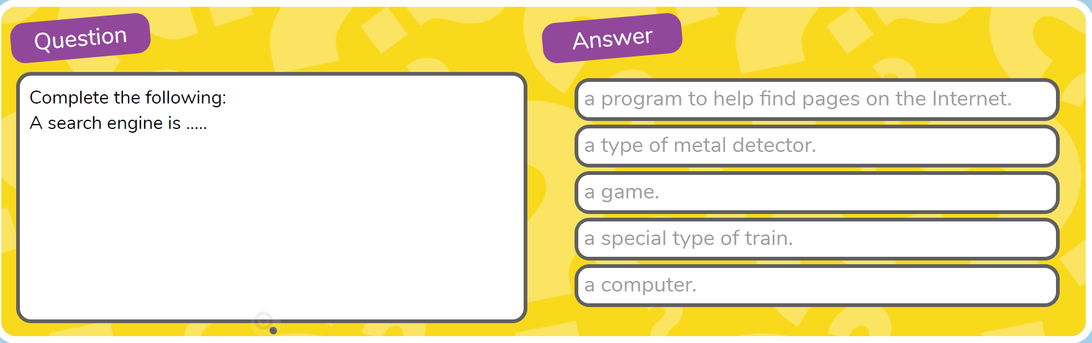

Answers
- Connected
- The internet includes the World Wide Web, email, online gaming and messaging.
- A browser
- Website
- Webpage
- The way to find a page on the Internet
- A program to help you find pages on the Internet.

